# **Case Study / Scenario**

## Demonstrate the scenario or the system entities and their relationships. Mention the properties or attributes for each entity along side cardinality. The unique identifier or primary keys of each entity should also be mentioned.

|  |  |  |
| --- | --- | --- |
| Student ID1: Name: | StudentID3: Name: | |
| StudentID2: Name: | StudentID4: Name: | |
| **CO2**: Understand the fundamental concepts underlying database systems and gain hands-on experience with ER diagram Case study | | |
| **PO-c2:** Develop process for complex computer science and engineering problems considering cultural and societal factors. | | Marks |

**Supershop Stockroom Supply Availability Management System**

**Case Study (Scenario):**

In a super shop stockroom management system, each product stored in the stockroom is tracked for availability and restocking. A product is supplied by exactly one supplier, but each supplier can provide many products. The system ensures that every product belongs to one specific category, such as food, beverages, or household goods, and each category must have at least one product. To manage inventory efficiently, the system tracks the current stock levels, reorder points, and expiration dates (if applicable) of each product.

The Supplier entity represents the vendors who provide products to the store. Each supplier has a unique Supplier ID, and the system stores additional information such as the supplier's name, contact details, and the categories of products they supply. Suppliers can be associated with multiple products, ensuring that various items, like groceries or household items, can be sourced from different suppliers.

The Product entity represents the items stored in the stockroom. Each product is uniquely identified by a Product ID and has attributes such as Product Name, Category, Quantity in Stock, Reorder Level, Shelf Life, and Unit Price. This allows the system to monitor which products are in stock and when to trigger restocking orders based on the stock level reaching the reorder point. Perishable goods, like food items, also include shelf life information to manage expiration dates effectively.

The Store Branch entity represents each physical location of the super shop. Every branch is identified by a Branch ID and stores details like Branch Location, Manager Name, Stockroom Capacity, and Current Stock Levels. This helps each branch monitor its stock and ensure it has sufficient inventory to meet customer demand. Each branch may have a different stockroom capacity, influencing how much product it can hold.

Finally, the Restocking Order entity manages the process of replenishing products in the stockroom. Each restocking order is identified by an Order ID and tracks the Order Date, Product ID, Supplier ID, Order Quantity, Delivery Date, and Order Status. The system keeps track of when an order was placed, how many units were ordered, and whether the order has been delivered or is still pending. Each restocking order is tied to a specific product and supplier, ensuring that inventory is replenished in a timely manner.

The relationships between these entities ensure that the system can efficiently manage the availability of products in the stockroom, preventing stockouts and ensuring smooth operations across all store branches. The system helps in forecasting demand, managing supplier relationships, and maintaining optimal inventory levels.

Entities and Relationships

1. Supplier
   * Attributes:
     + SupplierID (Primary Key)
     + SupplierName
     + ContactDetails
     + CategoriesSupplied
   * Cardinality:
     + One supplier can provide many products (1 to many relationship with Product).
     + Each product is supplied by exactly one supplier (N:1 relationship with Product).
2. Product
   * Attributes:
     + ProductID (Primary Key)
     + ProductName
     + CategoryID (Foreign Key referencing Category)
     + QuantityInStock
     + ReorderLevel
     + ShelfLife (in months)
     + UnitPrice
   * Cardinality:
     + Each product belongs to one category (N:1 relationship with Category).
     + Each product is supplied by one supplier (N:1 relationship with Supplier).
     + Each product can be part of many restocking orders (1

relationship with RestockingOrder).

1. Category
   * Attributes:
     + CategoryID (Primary Key)
     + CategoryName
   * Cardinality:
     + Each category can have many products (1

relationship with Product).

* + - Each product must belong to one category (N:1 relationship with Product).

1. Store Branch
   * Attributes:
     + BranchID (Primary Key)
     + BranchLocation
     + ManagerName
     + StockroomCapacity
     + CurrentStockLevels
   * Cardinality:
     + Each store branch can have many products in stock (1

relationship with Product).

* + - Each product may be available in multiple branches (M

relationship with Product).

1. Restocking Order
   * Attributes:
     + OrderID (Primary Key)
     + ProductID (Foreign Key referencing Product)
     + SupplierID (Foreign Key referencing Supplier)
     + OrderQuantity
     + OrderDate
     + DeliveryDate
     + OrderStatus
   * Cardinality:
     + Each restocking order is linked to one product (N:1 relationship with Product).
     + Each restocking order is linked to one supplier (N:1 relationship with Supplier).
     + Each product can have multiple restocking orders (1

relationship with RestockingOrder).

**Unique Identifiers:**

* SupplierID for Supplier
* ProductID for Product
* CategoryID for Category
* BranchID for Store Branch
* OrderID for Restocking Order

# **ER Diagram**

## Provide the jpg/png file of your ER diagram after the drafts being checked by your course teacher

## you can use any of the diagraming tools like Dia Diagram, visio, lucidchart, draw.io etc

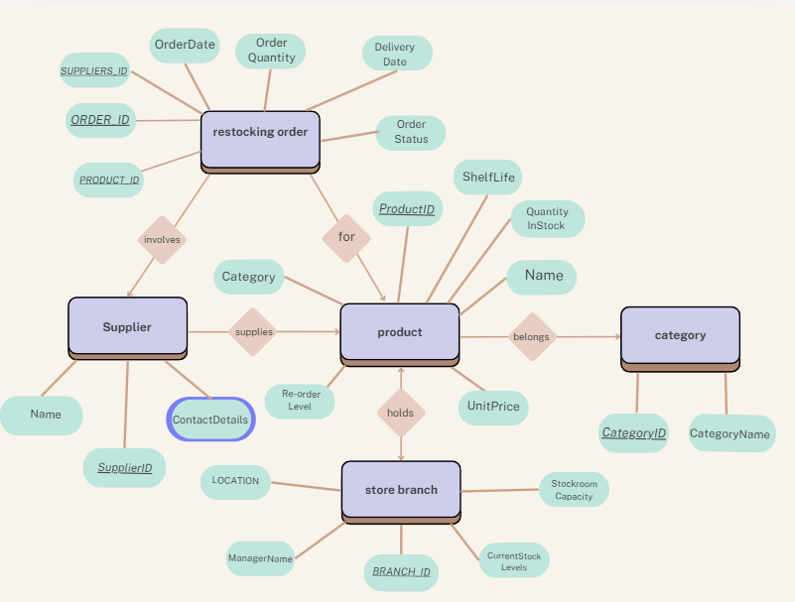

# **Normalization**

## Show the process of normalization up to 3NF for all the relations in the ER diagram

For product table:

There is no multivalued item here. Nothing is removed.

2NF table: Partial dependencies are removed.

1. Product table:

1. Category table:

1. Supplier Table:

3NF table: No transitive dependency.

Unnormalized table for category, suppliers and orders:

1NF:

Multivalued columns are individualized.

2NF:

Partial dependencies are removed.

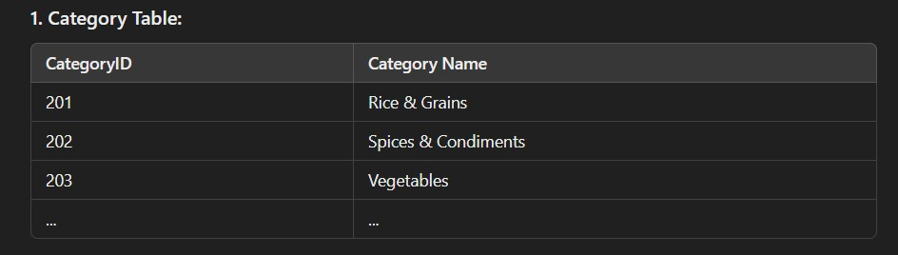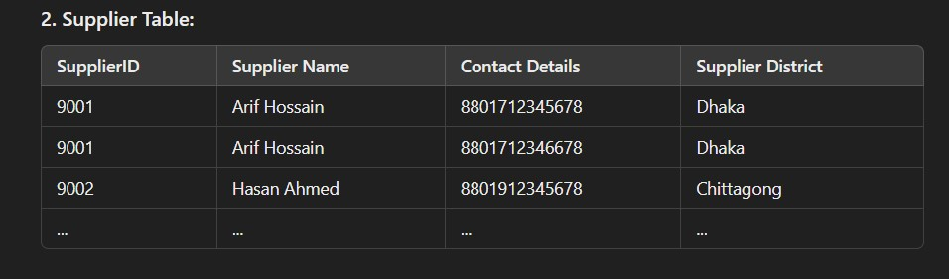

1. Restocking order table:

3NF:

Category & order table remains unchanged.

The supplier table has a few more divisions, removing transitive dependency:

1. Supplier contact details:

1. Supplier District table:

For storebranch:

1NF no multivalued data:

2NF: Parital dependency is removed.

3NF: no change

**FINALISATION**

**Finalisation**

1. A screenshot of a menu

   Description automatically generatedCategory table:
2. Supplier Table:

1. Supplier contact details:

1. Supplier District table:

5 & 6: Storebranch table and manager table:

1. Product table:

1. Restocking order table:

